Variables excluded based on correlation matrix. 10 fold cross validation used to calculate accuracy.

GLRLMS, GLCM (7), Hu moments 22/25 features

1. 3 variables excluded; no PCA; classes 1&2 and 3&4 lumped

Best classifier: KNN

Accuracy = **83.1%**

AUC = 0.83

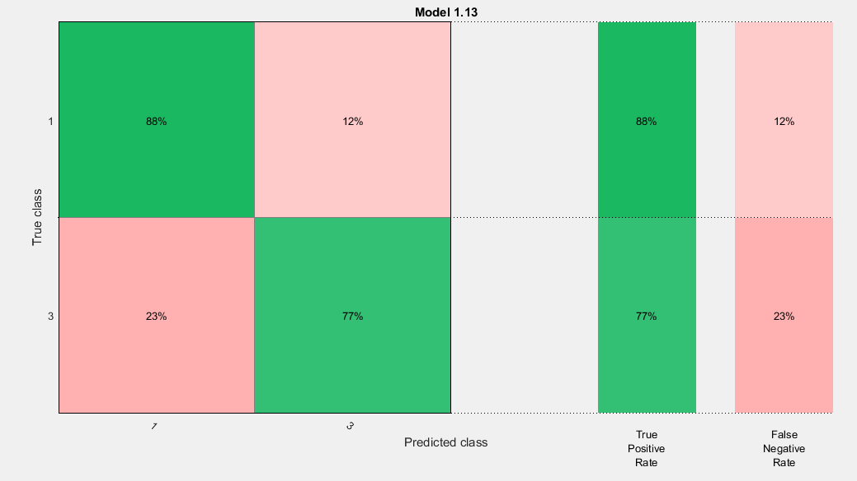

1. 3 variables excluded; no PCA; classes 1&2 and 3&4 lumped

Best classifier: KNN&SVM

Accuracy = **82.9%**

AUC = 0.82

GLCM (20) + GLRLMS(11) + Hu(7)

1. No variables excluded; no PCA; lumped classes

Best classifier: KNN

Accuracy **= 90.9%**

AUC = 0.91

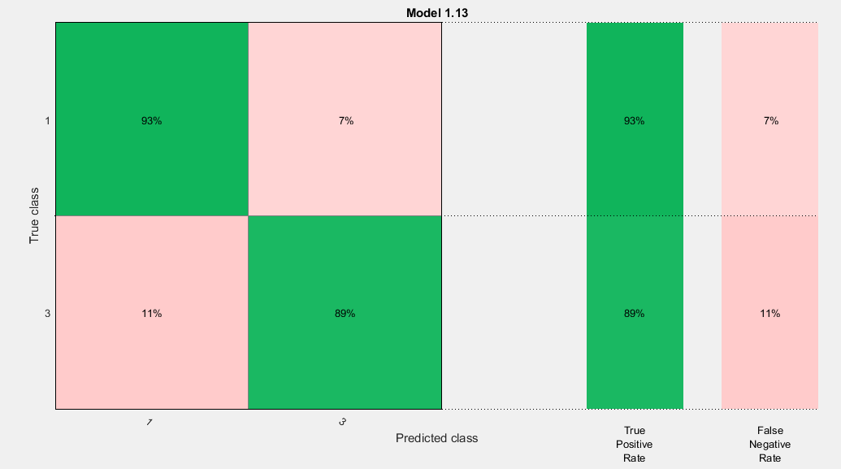

1. No variables excluded; no PCA; lumped classes

Best classifier: KNN

Accuracy **= 92.2%**

AUC = 0.92

1. No variables excluded; no PCA; lumped classes

Best classifier: KNN

Accuracy **= 89.6%**

AUC = 0.90

1. 7 variables excluded; no PCA; lumped classes

Best classifier: KNN

Accuracy **= 87%**

AUC = 0.87

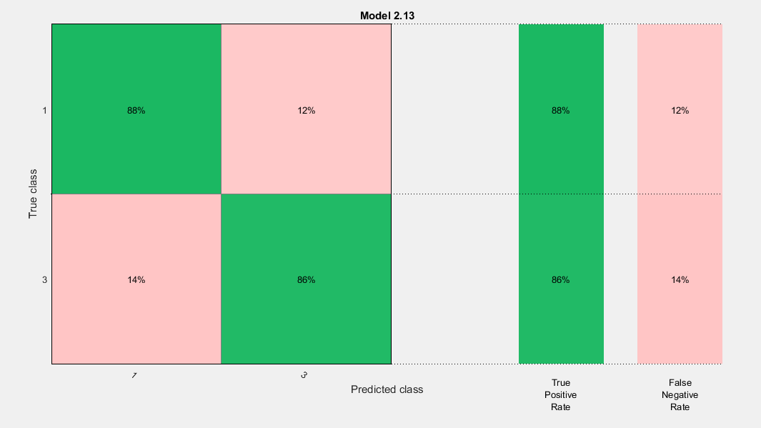

1. 7 variables excluded; no PCA; lumped classes

Best classifier: KNN

Accuracy **= 84.4%**

AUC = 0.85

1. 7 variables excluded; no PCA; lumped classes

Best classifier: KNN

Accuracy **= 84.4%**

AUC = 0.84

GLRLMS + GLCM

1. No variables excluded; no PCA; lumped classes

Best classifier: KNN

Accuracy **= 85.7%**

AUC = 0.85

Laws(9) + GLRLMS(11) + GLCM(20) + Hu(7)

1. No variables excluded; no PCA; lumped classes

Best classifier: KNN

Accuracy **= 84.4%**

AUC = 0.84

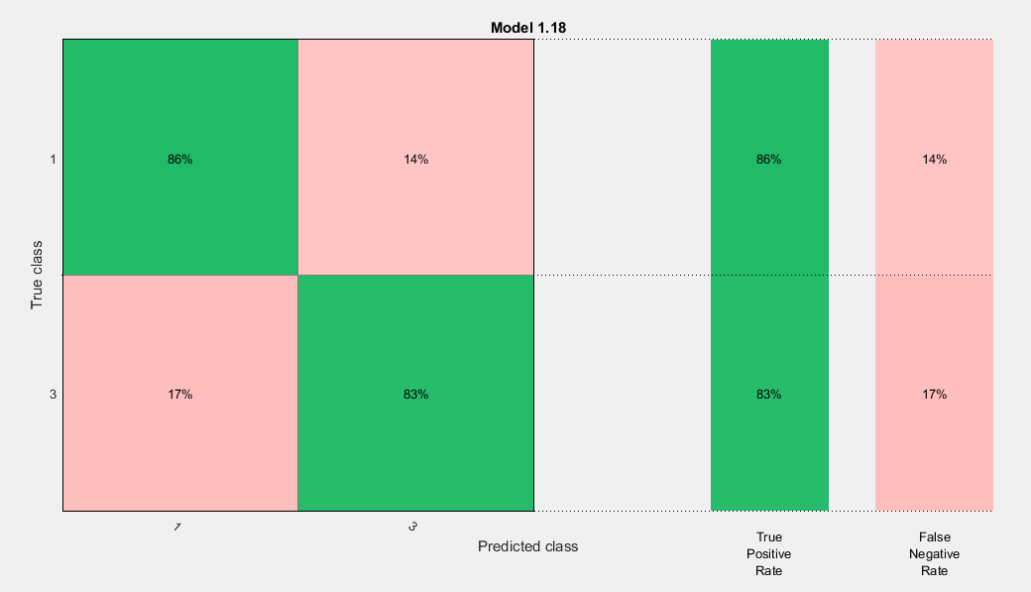

1. 6 variables excluded; no PCA; lumped classes

Best classifier: Ensemble

Accuracy **= 80.5%**

AUC = 0.85